1. What is the Namenode's URI and which file is it configured in?

**Ans:** URI pointing to the machine used as the NameNode. We will configure in core-site.xml file.

1. Where on a local file system will Namenode store its image and which file is it configured in?

**Ans:** edit logs files- edit file load into ‘log’, FsImage files- fsimage file is load into **‘**in-memory’. This Namenode is used for configured on hdfs-site.xml. the metadata in the form of FSI IMAGE and also used for checkpointing.

1. Where on a local file system will Datanode store its blocks and which file is it configured in?

**Ans:** Datanode stores actual data and performs various operations like block creation, deletion and replication according to instruction of Namenode. This DataNode is used for configured on hdfs-site.xml.

1. What is the block replication and which file is it configured in?

**Ans:** The replication factor is a property that can be set in the HDFS configuration file that will allow to adjust the global replication factor for the entire cluster. The replication factor was set to 3 (default value in HDFS) there would be one original block and two replicas.

**Perform**

1. Start HDFS and verify that it's running

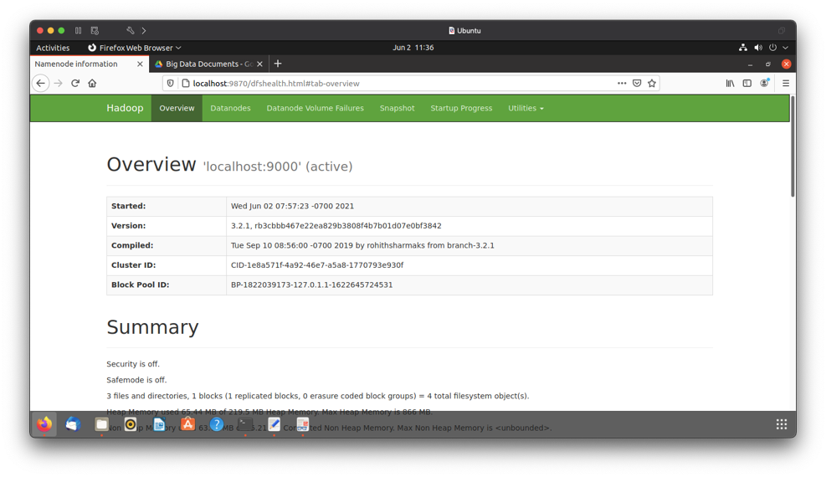

2. Create a new directory /exercise1 on H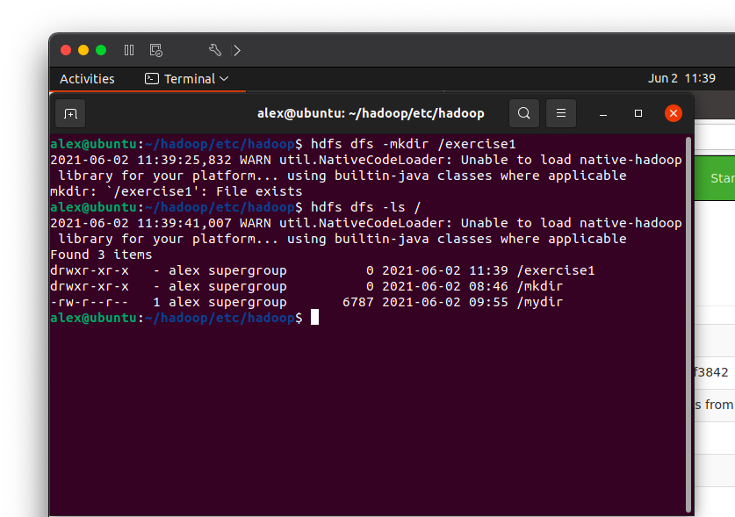

3. Upload GitHub repo sample_data/deckofcards.txt to HDFS under /exercise1 directory

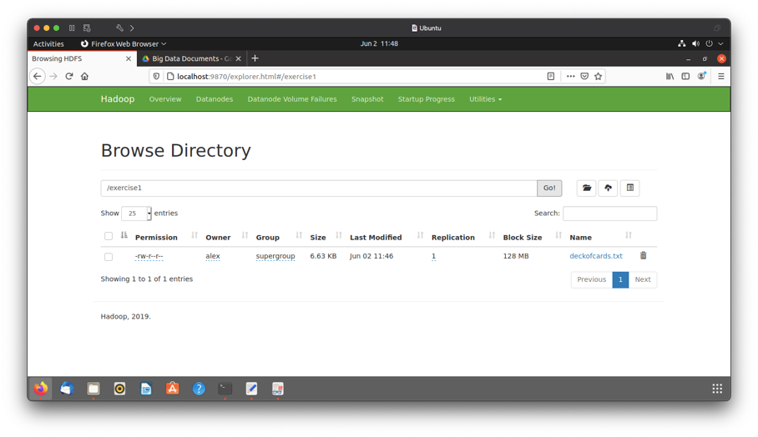

4. View the content of the /exercise1 directory

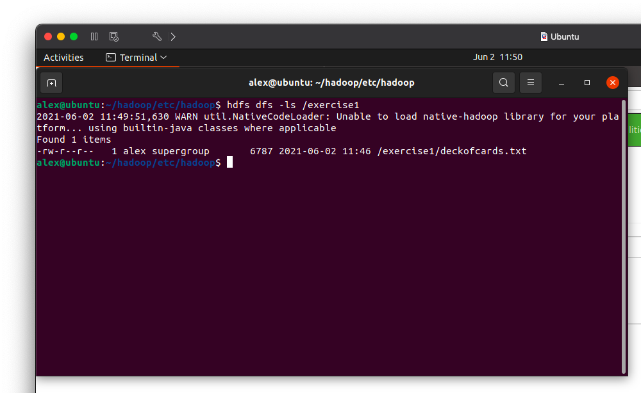

5. Determine the size of the hamlet.txt file in KB that resides on HDFS (not local directory)

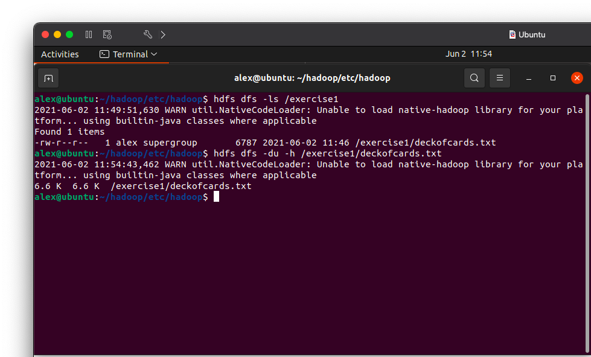

1. Print the first 25 lines to the screen from deckofcards.txt on HDFS

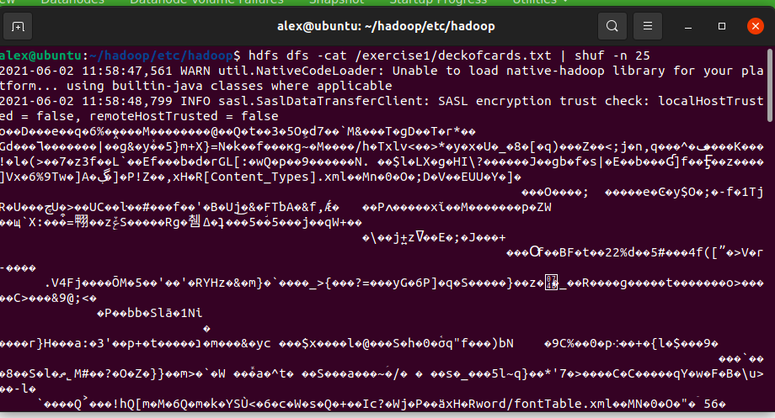

1. Copy deckofcards.txt to deckofcardsCopy.txt

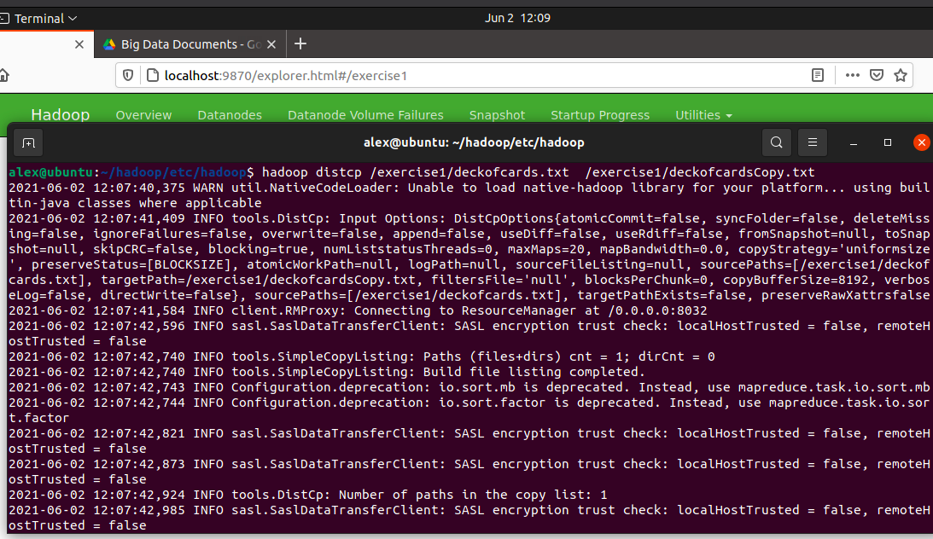

1. Copy deckofcards.txt back to local file system and name it deckofcards.copy.txt
2. Check the entire filesystem for inconsistencies/problems

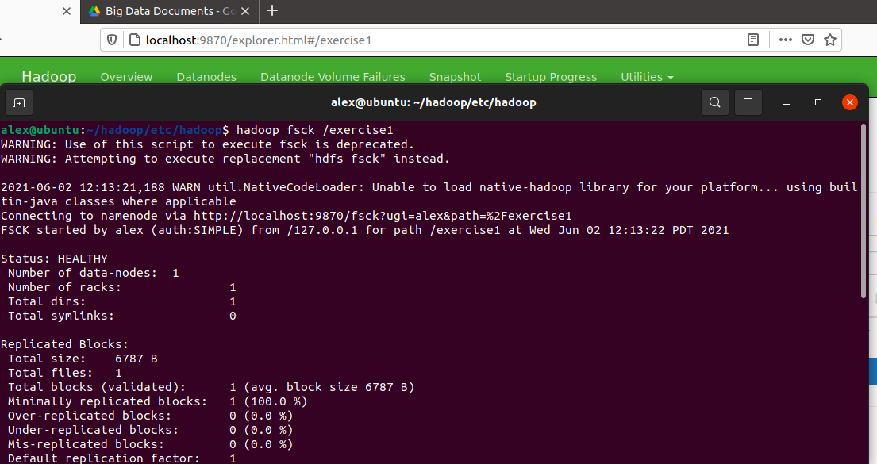

1. Delete deckofcards.txt from HDFS

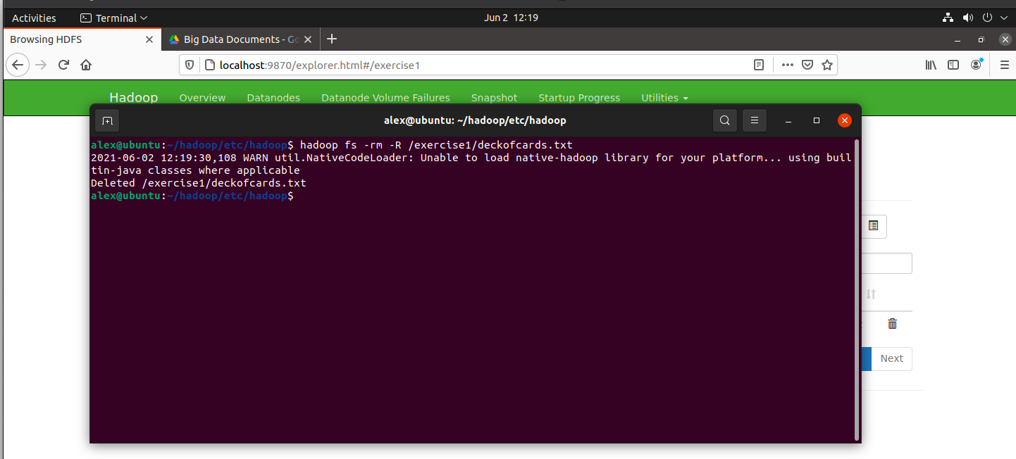

1. Delete the /exercise1 directory from HDFS

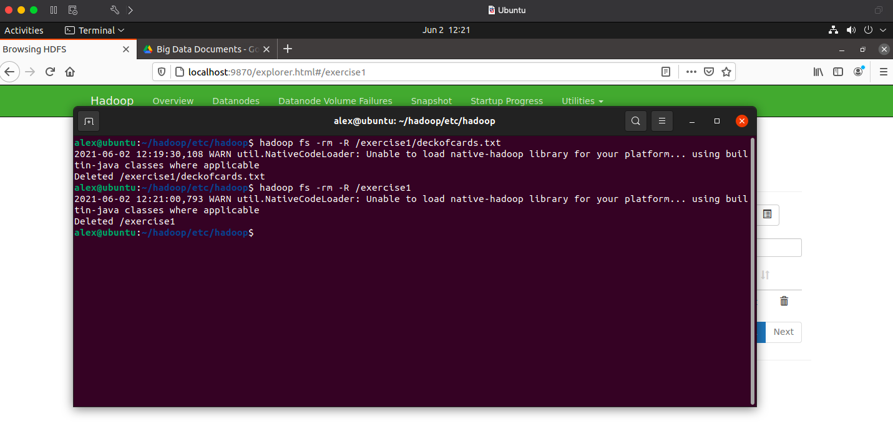

1. Take a second to look at other available shell options.

**Ans:** hdfs dfs -help